Rung 4 - F6 to Fc in Byte 3 of the DSID request packet.

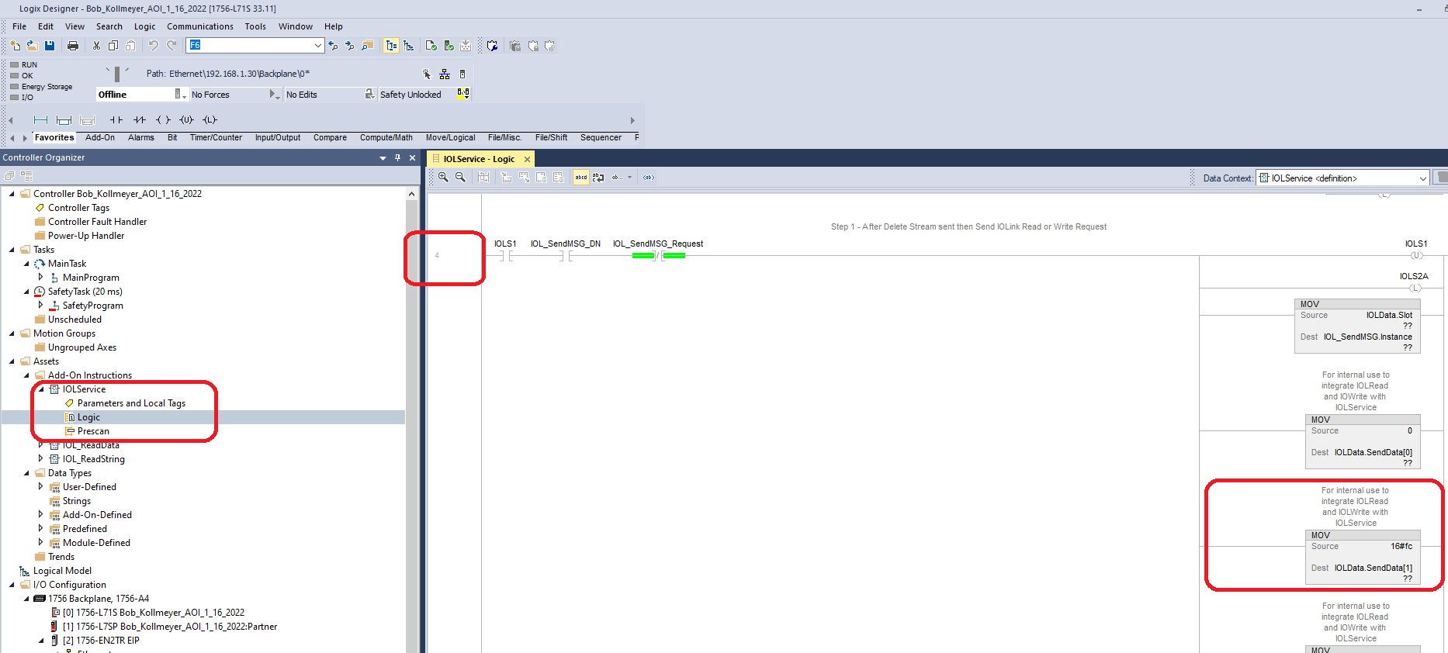

Rung 7 – Change F7 to Fd in the response packet

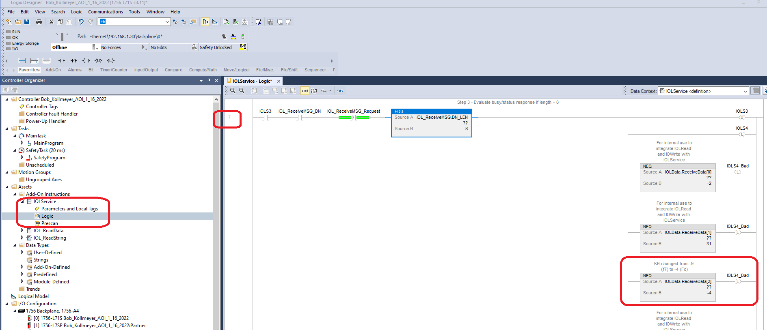

Rung 11 – F7 to Fd

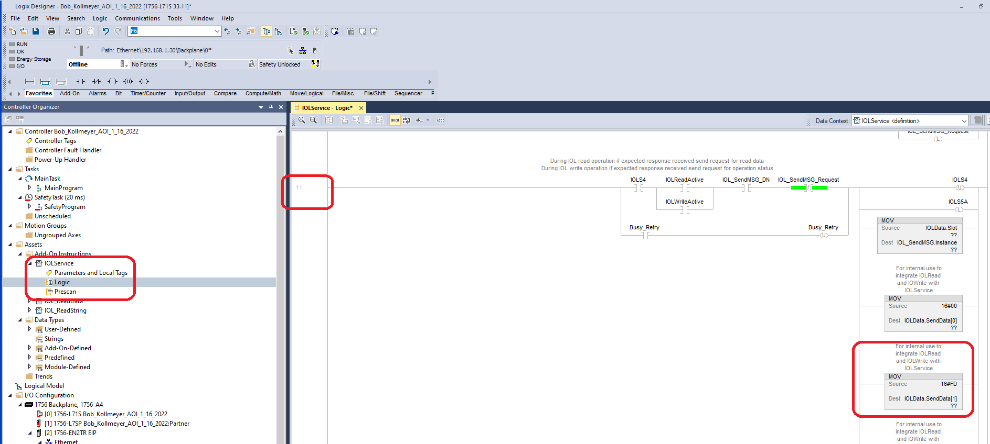

Rung 14 – F7 to Fd

